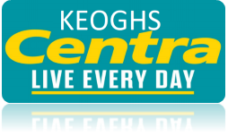
Dear Parent/Guardian
We are pleased to provide you with an update that schools lunches are due to recommence on Monday 7th September.
The new menus will be live on the ordering site by 31 August. For the first week, all orders must be placed before 2:00 PM on Thursday 4 September.
If your child already has a PIN: log in at keoghscentra.com, select School Lunch Login, and place your order before the deadline.
If your child is new to the school: request a PIN first and when received log in to place the order. Your PIN will become active within 24 hours.
To Request a new PIN
- Visit: keoghscentra.com
- Go to School Lunch Login tab.
- Select request password. (have the school’s unique code and child’s room number ready)
- The PIN will be emailed back to you.
- You will also receive a 2nd email when the PIN is ‘live’.
Once your PIN is ‘live’ place a lunch Order
- Visit: keoghscentra.com
- Go to School Lunch Login tab.
- Login using your PIN
Your unique school code should be emailed to you, please contact Keoghs if you don’t have it.
The school lunch delivery service delivers the fresh lunches to your school each day.
If you have any questions, please do not hesitate to contact us.
Thank you for your support
Keoghs Centra

